Project 3 Gabor Stefan-Ioan Computer Vision

The main idea from my solutions at Task 1 and 2 was to identify the darts arrows from image, by subtracting the template image of the target dart-board, from the current one, and after applying some operations on the image like template matching with the template image, Gaussian filter, threshold difference, median blur.
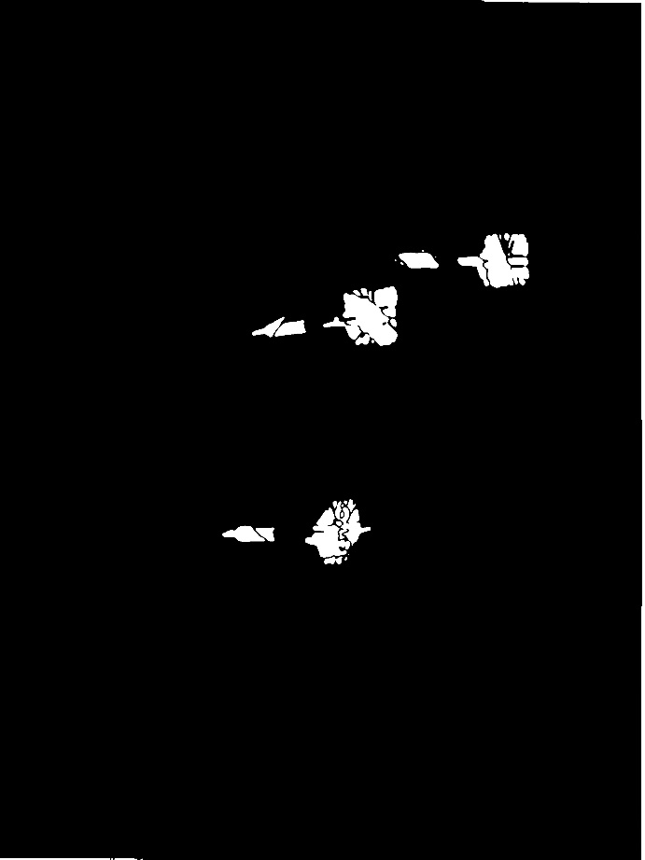
After that we have some white arrows on a black background, now we will be iterating over each pixel from left to right through columns in the region of the target board, we check if the pixel is white, and if the mean from a square starting from that pixel, is bigger than a threshold, it means that there is a peak from the arrow, and if a new square is near or intersects other founded, means that is the same arrow there.
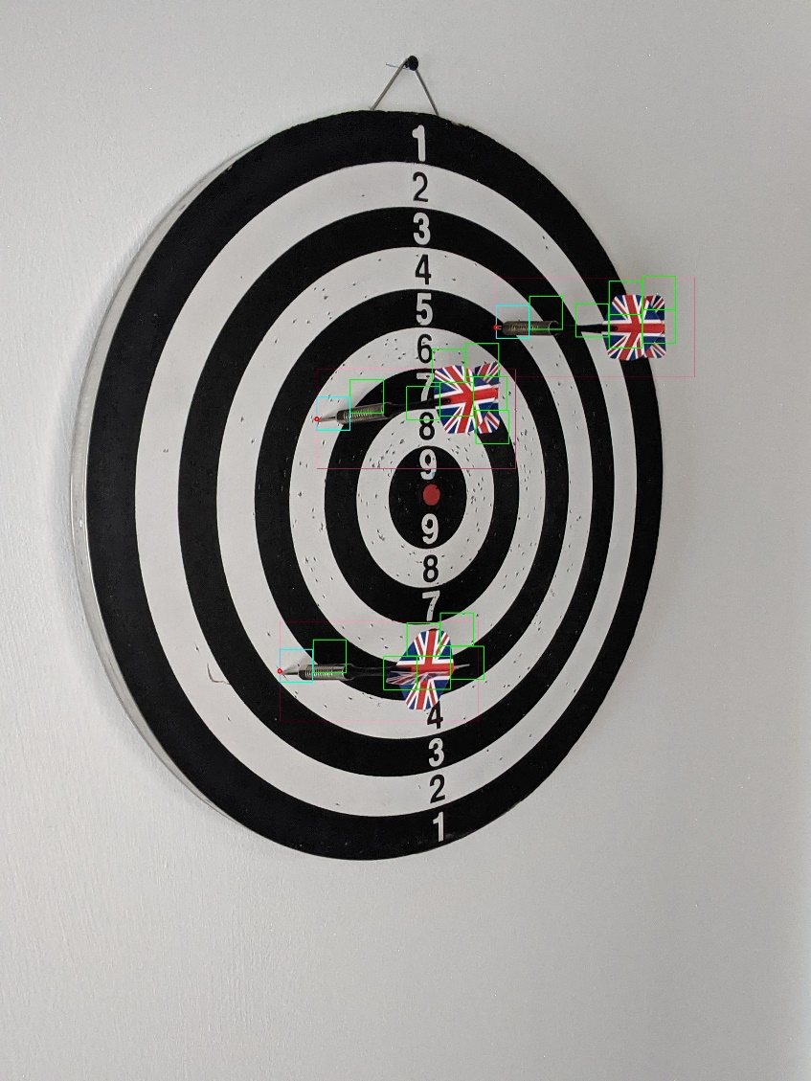

This is an image that explains how the algorithm works: where is a red dot there are the first white pixels found from where the mean of the rectangle is bigger than a threshold, first rectangles are the blue ones, and other rectangles crossing the threshold near first ones or which their corresponding point are inside in regions determined by peaks found, are colored in green and represents the other parts from the arrows already found.

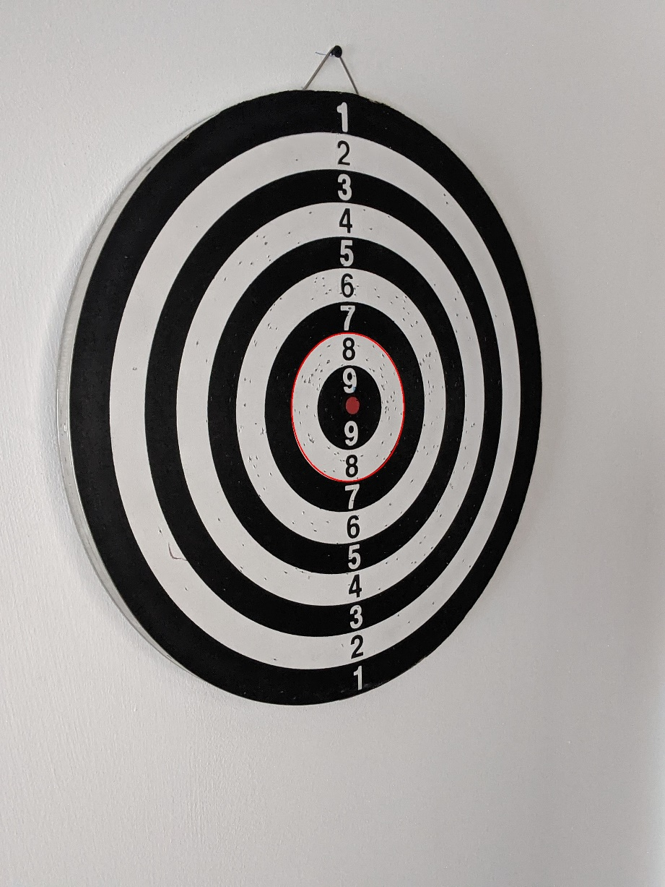

After the arrow peaks are found, each region of points is approximated with and ellipse, and if the peaks of the dart arrows are inside that points are counted, and after each image, the algorithm returns the number of dart arrows on target board, and the points gained by each arrow in txt files.
The same behavior is for Task 2, but with more regions for points:

